***Dt : 20/9/2022***

***Execution flow of above program:***

***ClassFiles:***

***PClass.class***

***CClass.class***

***DemoInheritance1.class(MainClass)***

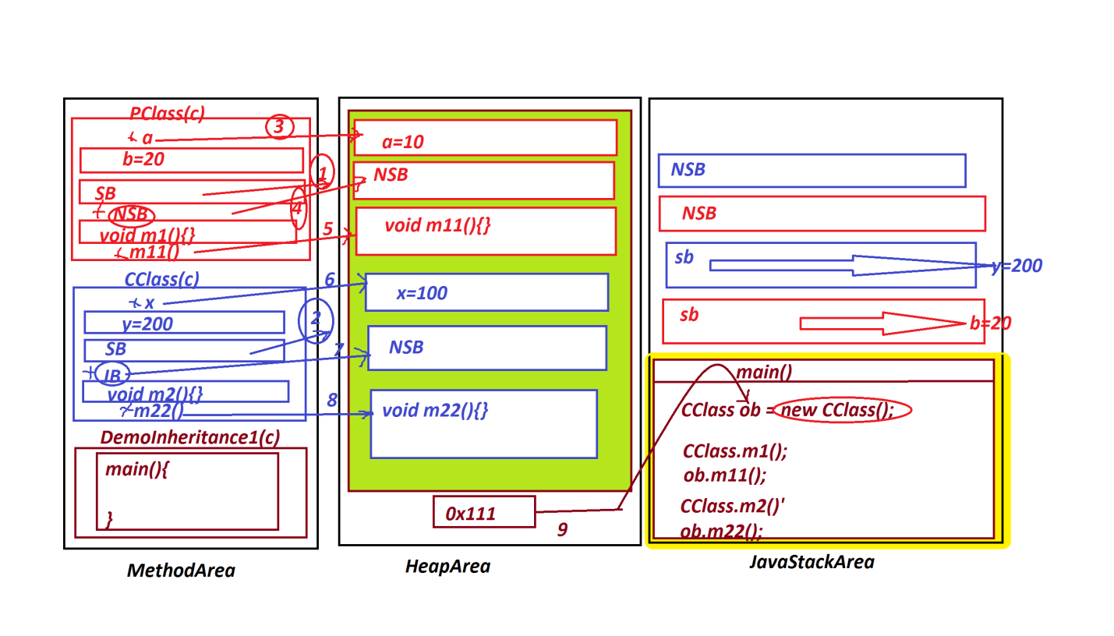

***Note:***

***=>In Inheritance process PClass is loaded first on to MethodArea***

***and then the CClass is loaded.***

***=>In Inheritance process while Object creation PClass instance***

***members will get the memory first and the CClass Instance members***

***will get the memory.***

***=>In Inheritance process the object is created for CClass,but***

***the CClass object will hold all the Instance members of PClass.***

***=>All the static members of PClass are available to CClass,which***

***means can be accessed with CClass_name.***

***----------------------------------------------------------***

***Case-2 : Constructors from the PClass/SuperClass***

***(i)0-parameter constructor in PClass/SuperClass***

***=>When there is 0-parameter constructor in PClass then the***

***Compiler at compilation stage will add super() to the constructor***

***of CClass and which is PClass Con_Call***

***(ii)Parameterized Constructor in PClass/SuperClass***

***=>when there is Parameterized constructor in PClass then we must***

***add super() to the CClass constructor to pass parameters.***

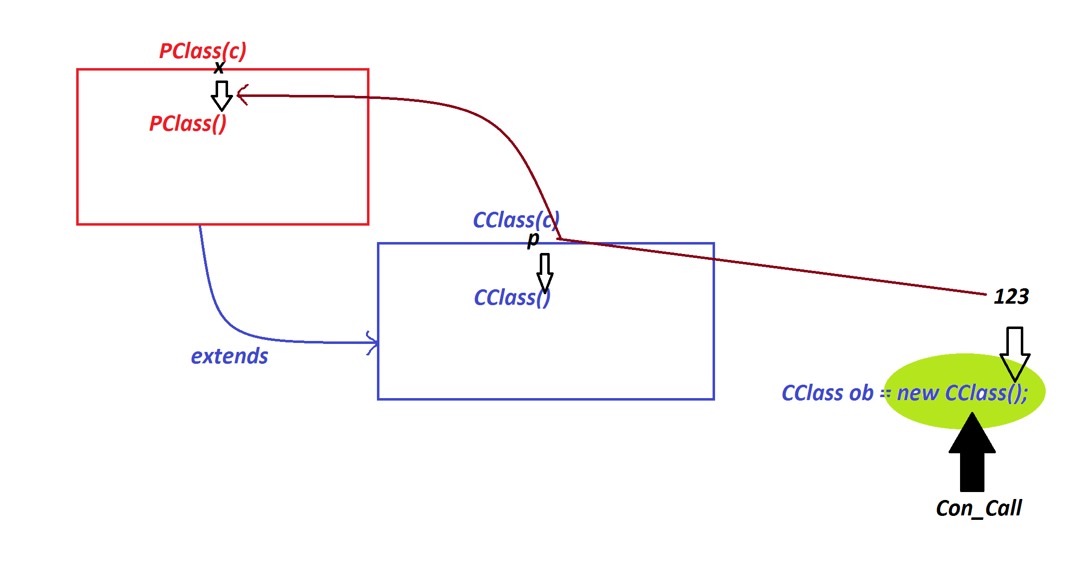

***Ex:***

***PClass.java***

***package test;***

***public class PClass {***

***public PClass(int x) {***

***System.out.println("===PClass con()====");***

***System.out.println("The value x:"+x);***

***}***

***}***

***CClass.java***

***package test;***

***public class CClass extends PClass{***

***public CClass(int p) {***

***super(p);//PClass_Con_Call***

***}***

***}***

***DemoInheritance2.java(MainClass)***

***package maccess;***

***import test.*;***

***public class DemoInheritance2 {***

***public static void main(String[] args) {***

***CClass ob = new CClass(123);//CClass_Con_Call***

***}***

***}***

***============================================================***

***faq:***

***define Method Overriding process?***

***=>The method with same method Signature in PClass and CClass,***

***in this process PClass method is replaced by CClass method while***

***object creation process is known as 'Method Overriding process'.***

***=>Same method signature means,***

***same return_type***

***same method_name***

***same para_list***

***same para_type***

***Ex :***

***PClass.java***

***package test;***

***public class PClass {***

***public int a;***

***public static int b;***

***public PClass(int a,int b)***

***{***

***this.a=a;***

***PClass.b=b;***

***}***

***public void m1()***

***{***

***System.out.println("====PClass Instance m1()====");***

***System.out.println("The value a:"+a);***

***System.out.println("The value b:"+b);***

***}***

***public static void m11()***

***{***

***System.out.println("====PClass Static m11()====");***

***System.out.println("The value b:"+b);***

***}***

***}***

***CClass.java***

***package test;***

***public class CClass extends PClass{***

***public CClass(int a,int b) {***

***super(a,b);//PClass_Con_Call***

***}***

***public void m1()***

***{***

***System.out.println("====CClass Instance m1()====");***

***System.out.println("The value a:"+a);***

***System.out.println("The value b:"+b);***

***}***

***public static void m11()***

***{***

***System.out.println("====CClass Static m11()====");***

***System.out.println("The value b:"+b);***

***}***

***}***

***DemoInheritance3.java(MainClass)***

***package maccess;***

***import java.util.*;***

***import test.*;***

***public class DemoInheritance3 {***

***public static void main(String[] args) {***

***Scanner s = new Scanner(System.in);***

***System.out.println("Enter the value of a:");***

***int a = s.nextInt();***

***System.out.println("Enter the value of b:");***

***int b = s.nextInt();***

***CClass ob = new CClass(a,b);//CClass_Con_Call***

***ob.m1();//CClass_Instance_method***

***CClass.m11();//CClass_Static_method***

***s.close();***

***}***

***}***

***o/p:***

***Enter the value of a:***

***121***

***Enter the value of b:***

***123***

***====CClass Instance m1()====***

***The value a:121***

***The value b:123***

***====CClass Static m11()====***

***The value b:123***

***===========================================================***